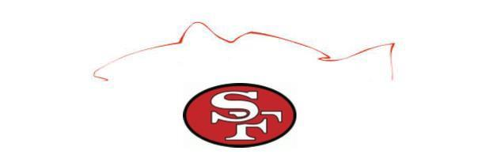

14th Annual Santa Fe Lady Raider Inshore Slam
October 3rd, 2026
Sea Hag Marina – Steinhatchee, Florida

HEAVIEST LEGAL FISH
(Red Fish, Trout, Sting Ray and Shark excluded)
1ST Place $75
2nd Place $50
3rd Place $25
HEAVIEST RED FISH
1ST Place $500
2nd Place $200
3rd Place $100
HEAVIEST TROUT
(Slot fish only 15-19”)
1ST Place $500
2nd Place $200
3rd Place $100

CALCUTTA
(Trout over 19” only,
Side pot buy-in)
20$ per Angler
MOST SPOTS
RED FISH
$200

JUNIOR ANGLER DIVISION
(Any legal fish accepted)
1ST Place $75
2nd Place $50
3rd Place $25

Call 352-316-3908 for more information.
Email entry forms to: SFRaidersoftball@hotmail.com

Angler’s Social – Music

Sea Hag Marina will be hosting the “Angler’s Social” on Friday, October 2nd
Right after Captain’s meeting (approximate time 7:00 p.m.)
Come give your fishing report, true or not, and pick up some last-minute tips.
The Tiki bar will be open for business during this event.

TOURNAMENT ENTRY FORM

Captain Name (please print): ________________________________________________________
Address: ____________________________________________________________________________
Cell Phone: ___________________________ Email: _______________________________________
Boat Make: ___________________ Model & Length: _____________________________________
Boat Registration: ___________________________________________________________________
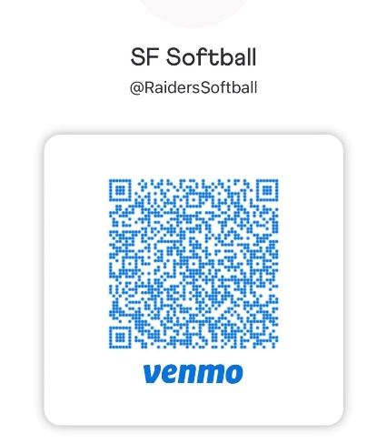
Adults $50 per Angler before August 31st (after that date is $60)

Junior Angler (12 years and younger) $25
The first 50 paid entries will receive a free tournament shirt

Name of Anglers Shirt Size
_____________________________________ _____________________
_____________________________________ _____________________
_____________________________________ _____________________
_____________________________________ _____________________

Total number of anglers on boat________ Total Boat entry fee: $__________________
Lady Raider player to which boat is assigned: _____________________________________

“MANDATORY” CAPTAIN’S MEETING ON Friday, 10/2/26 at 6:30 pm
(One representative from each boat must be present at Sea Hag Marina)
The following tournament rules will be used and will be interpreted solely by the Tournament Committee and all decisions are final.

- INDIVIDUAL TOURNAMENT: This is an individual tournament. All prize money will be awarded to one individual.
- TOURNAMENT COMMITTEE: The committee will consist of Santa Fe High School tournament reps.
- ELIGIBILITY: All Florida Saltwater Licensed Anglers.
- HEADQUARTERS/DATE: Sea Hag Marina, 322 Riverside Dr., Steinhatchee, FL 32359 – October 3, 2026
- ENTRY FEE: $50 per angler before Sept. 5th and the cost goes to $60 after that date. Participants MUST register prior to the start of the tournament.
- DEPARTURE & END TIME: Safe light until 3pm. Lines in the water 30 minutes before sunrise. No boat checks. Weigh-in will open at 2pm and close at 3pm. Anglers must return by boat and be in line at the stage with poker chip and fish in hand by 3pm.
- TACKLE & EQUIPMENT: Artificial lures, live bait may be used. Spearfishing or gigging will not be allowed. All fish must be caught on rod and reel.
- SAFETY & SPORTSMANSHIP: Safe boating and fishing practices must be observed.
- PERMITTED FISHING LOCATIONS: You must start in Steinhatchee, Florida but you are permitted to travel as far as you would like without touching land during tournament hours.
- SCORING: All fish must follow FWC regulations. Heaviest Trout - slot fish only 15-19". Calcutta - Trout over 19" only, every angler on the boat must buy in. Pays out 50%. Heaviest Redfish - 18-27". Most Spots - the same redfish you weigh for the heaviest category will count for spots, spots must be separated (not touching, to count as 1). Heaviest Legal Fish - anything legal can be weighed in this category except redfish, trout, sharks, and stingrays. Jr. Angler - anything legal will be accepted other than sharks and stingrays.
- TIES: In case of a tie, the winner will be the individual that weighed in the earliest.

By signing below, I hereby affirm that I have read and understand all tournament rules and that I will abide by all decisions made by the tournament rules committee. The Tournament Committee, sponsors, or Santa Fe High School are not responsible for accidents or injuries received due to participating in this tournament.

Captain Signature: ___________________________________________________________ Date: ___________________________________
Please mail checks to: Santa Fe Softball Boosters, P.O. Box 1651, Alachua, FL 32616

